StorageCraft ImageManager Monitoring Configuration Guide

Use these steps to upload and configure the necessary components in order to monitor ImageManager managed folders.

Pre-requisites: N-central 9.2.1.251

**Only tested with ImageManager 6.5!**

All referenced files are available at the location you retrieved this document.

Upload the custom services

a. Download **StorageCraft ImageManager.xml**

b. Login to the N-central Admin Console (NAC)

c. Select Custom Services

d. Upload both custom service xml files:

**StorageCraft ImageManager.xml**

**StorageCraft ImageManager Managed Folder List.xml**

Upload the Service template

a. SO Level > Configuration > Monitoring > Service Templates

b. Click Import

c. Import the service template xml file: **StorageCraft ImageManager Service Template.xml**

Create a filter

a. SO > Configuration >Filters

b. Name: **StorageCraft** **ImageManager Devices**

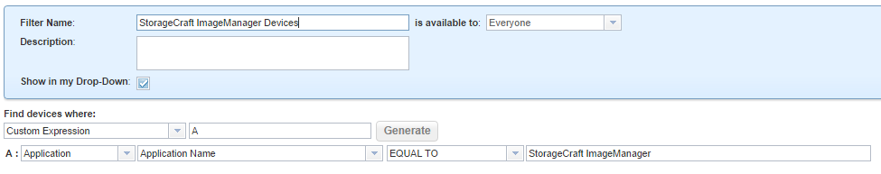

Upload the script to the Script and Software Repository

a. SO > Configuration > Script/Software Repository

b. Name: **ImageManagerPoll.exe**

Create a Scheduled Task Profile

a. SO > Configuration > Scheduled Tasks > Profiles

b. Select Add

c. Name: **StorageCraft ImageManager job polling profile**

d. Select Add > Scripting

c. Schedule **ImageManagerPoll.exe** to run hourly (no parameters needed)

Create a Rule

a. SO > Configuration > Monitoring > Rules

b. Click Add

Name: **StorageCraft ImageManager**

Filter: **StorageCraft ImageManager Devices**

Scheduled Task Profile: **StorageCraft ImageManager job polling profile**

Service Template: **StorageCraft ImageManager**

Customers: all

Propagate to all new customer/sites: yes

Configure Notifications

a. SO > Configuration > Monitoring > Notifications

b. Select the Backup Manager notification profile

c. Add the appropriate recipients

d. Select the Trigger Details tab

e. Select the Backup Manager trigger

f. Add the StorageCraft ImageManager service

Configure the Managed Folder name on each server

Wait until the first script run has completed on all servers.

a. SO > All Devices View

b. Select the **StorageCraft ImageManager Devices** filter

c. Select each server

d. If you are unsure of the managed folder name, click on the **StorageCraft ImageManager Managed Folder List** service to copy the name to clipboard

e. Select the **StorageCraft ImageManager** service

f. Select the Service Details tab

g. Enter the Managed folder name

h. For all other Managed Folders on this device, add another instance of the **StorageCraft ImageManager** service and configure